## **Урок 17_ Домашнє завдання**

## **Тестування API. JSON. REST**

**Перший рівень**

1. В Google docs створи 5 тест-кейсів для функціонального тестування сайту <https://automoto.ua/uk/> (5 найбільш пріоритетних тестів).

| **Test Case ID** | | BU_001 | **Test Case Description** | | Test the site registration form | | | | | |
| --- | --- | --- | --- | --- | --- | --- | --- | --- | --- | --- |
| **Created By** | |  | **Reviewed By** | |  | | **Version** | |  | |
|  |  |  |  |  |  |  |  |  |  |  |
| **QA Tester’s Log** | |  | | | |  |  |  |  |  |
|  |  |  |  |  |  |  |  |  |  |  |
| **Tester's Name** | | Alla | **Date Tested** | | 06.12.2022 | | **Test Case (Pass/Fail/Not Executed)** | | Pass | |
|  |  |  |  |  |  |  |  |  |  |  |
| **S #** | **Prerequisites:** | | |  | **S #** | **Test Data Requirement** | | | | |
| 1 | Оpen site https://automoto.ua/uk/ | | |  | 1 | Phone number - 38097-00-11-222 | | | | |
| 2 |  | | |  | 2 |  | | | | |
| 3 |  | | |  | 3 |  | | | | |
| 4 |  | | |  | 4 |  | | | | |
|  |  |  |  |  |  |  |  |  |  |  |
| **Test Conditions** | Check user registration on the site | | | | |  |  |  |  |  |
|  |  |  |  |  |  |  |  |  |  |  |
| **Step #** | **Step Details** | | **Expected Results** | | Pass / Fail / Not executed / Suspended | | |  | | |
| 1 | Сlick the "login" icon | | The login/registration window is open | | Pass | | |  | | |
| 2 | Enter a phone number | | А code was sent to the number | | Pass | | |  | | |
| 3 | Еnter the received code | |  | | Pass | | |  | | |
| 4 | Click "continue" | | The user page opens | | Fail | | |  |  |  |

2.

| **Test Case ID** | | BU_002 | **Test Case Description** | | Check the search form on the site | | | | | |
| --- | --- | --- | --- | --- | --- | --- | --- | --- | --- | --- |
| **Created By** | |  | **Reviewed By** | |  | | **Version** | |  | |
|  |  |  |  |  |  |  |  |  |  |  |
| **QA Tester’s Log** | |  | | | |  |  |  |  |  |
|  |  |  |  |  |  |  |  |  |  |  |
| **Tester's Name** | | Alla | **Date Tested** | | 06.12.2022 | | **Test Case (Pass/Fail/Not Executed)** | | Pass | |
|  |  |  |  |  |  |  |  |  |  |  |
| **S #** | **Prerequisites:** | | |  | **S #** | **Test Data Requirement** | | | | |
| 1 | Оpen site https://automoto.ua/uk/ | | |  | 1 | Car brand - Ford | | | | |
| 2 |  | | |  | 2 |  | | | | |
| 3 |  | | |  | 3 |  | | | | |
| 4 |  | | |  | 4 |  | | | | |
|  |  |  |  |  |  |  |  |  |  |  |
| **Test Conditions** | Check the search form by car brand | | | | |  |  |  |  |  |
|  |  |  |  |  |  |  |  |  |  |  |
| **Step #** | **Step Details** | | **Expected Results** | | Pass / Fail / Not executed / Suspended | | |  | | |
| 1 | Select the search form | |  | | Pass | | |  | | |
| 2 | Click on the "brand" field and check the car brand | | A list of car brands opens | | Pass | | |  | | |
| 3 | Click "search" | | The announcement page is open | | Pass | | |  | | |
|  |  | |  | |  | | |  |  |  |

3.

| **Test Case ID** | | BU_003 | **Test Case Description** | | Check the search form on the site | | | | | |
| --- | --- | --- | --- | --- | --- | --- | --- | --- | --- | --- |
| **Created By** | |  | **Reviewed By** | |  | | **Version** | |  | |
|  |  |  |  |  |  |  |  |  |  |  |
| **QA Tester’s Log** | |  | | | |  |  |  |  |  |
|  |  |  |  |  |  |  |  |  |  |  |
| **Tester's Name** | | Alla | **Date Tested** | | 06.12.2022 | | **Test Case (Pass/Fail/Not Executed)** | | Pass | |
|  |  |  |  |  |  |  |  |  |  |  |
| **S #** | **Prerequisites:** | | |  | **S #** | **Test Data Requirement** | | | | |
| 1 | Оpen site https://automoto.ua/uk/ | | |  | 1 | Car brand - Ford | | | | |
| 2 |  | | |  | 2 | Аutomatic gearbox | | | | |
| 3 |  | | |  | 3 | The color is white | | | | |
| 4 |  | | |  | 4 |  | | | | |
|  |  |  |  |  |  |  |  |  |  |  |
| **Test Conditions** | Check the advanced search form by car brand | | | | |  |  |  |  |  |
|  |  |  |  |  |  |  |  |  |  |  |
| **Step #** | **Step Details** | | **Expected Results** | | Pass / Fail / Not executed / Suspended | | |  | | |
| 1 | Select the search form | |  | | Pass | | |  | | |
| 2 | Click Advanced Search | | An advanced search form opens | | Pass | | |  |  |  |
| 3 | Choose the brand of transport | |  | | Pass | | |  | | |
| 4 | Choose gearbox | |  | | Pass | | |  | | |
| 5 | Choose a color | |  | | Pass | | |  |  |  |
| 6 | Click "show" | | The announcement page is open | | Pass | | |  |  |  |

4.

| **Test Case ID** | | BU_004 | **Test Case Description** | | Check the search form on the site | | | | | |
| --- | --- | --- | --- | --- | --- | --- | --- | --- | --- | --- |
| **Created By** | |  | **Reviewed By** | |  | | **Version** | |  | |
|  |  |  |  |  |  |  |  |  |  |  |
| **QA Tester’s Log** | |  | | | |  |  |  |  |  |
|  |  |  |  |  |  |  |  |  |  |  |
| **Tester's Name** | | Alla | **Date Tested** | | 06.12.2022 | | **Test Case (Pass/Fail/Not Executed)** | | Pass | |
|  |  |  |  |  |  |  |  |  |  |  |
| **S #** | **Prerequisites:** | | |  | **S #** | **Test Data Requirement** | | | | |
| 1 | Оpen site https://automoto.ua/uk/car/Ford | | |  | 1 |  | | | | |
| 2 |  | | |  | 2 |  | | | | |
| 3 |  | | |  | 3 |  | | | | |
| 4 |  | | |  | 4 |  | | | | |
|  |  |  |  |  |  |  |  |  |  |  |
| **Test Conditions** | Sort check | | | | |  |  |  |  |  |
|  |  |  |  |  |  |  |  |  |  |  |
| **Step #** | **Step Details** | | **Expected Results** | | Pass / Fail / Not executed / Suspended | | |  | | |
| 1 | Click "sort" | | A selection list opens | | Pass | | |  | | |
| 2 | Choose "from cheap to expensive" | | Sorting on the page from cheap to expensive. | | Pass | | |  |  |  |
|  |  | |  | |  | | |  | | |

5.

| **Test Case ID** | | BU_005 | **Test Case Description** | | Check writing a review | | | | | |
| --- | --- | --- | --- | --- | --- | --- | --- | --- | --- | --- |
| **Created By** | |  | **Reviewed By** | |  | | **Version** | |  | |
|  |  |  |  |  |  |  |  |  |  |  |
| **QA Tester’s Log** | |  | | | |  |  |  |  |  |
|  |  |  |  |  |  |  |  |  |  |  |
| **Tester's Name** | | Alla | **Date Tested** | | 06.12.2022 | | **Test Case (Pass/Fail/Not Executed)** | | Pass | |
|  |  |  |  |  |  |  |  |  |  |  |
| **S #** | **Prerequisites:** | | |  | **S #** | **Test Data Requirement** | | | | |
| 1 | Оpen site https://automoto.ua/uk/oplata-shtrafov | | |  | 1 | Name - Anna | | | | |
| 2 |  | | |  | 2 | Text - A large selection of cars | | | | |
| 3 |  | | |  | 3 |  | | | | |
| 4 |  | | |  | 4 |  | | | | |
|  |  |  |  |  |  |  |  |  |  |  |
| **Test Conditions** | Leave a review on the site | | | | |  |  |  |  |  |
|  |  |  |  |  |  |  |  |  |  |  |
| **Step #** | **Step Details** | | **Expected Results** | | Pass / Fail / Not executed / Suspended | | |  | | |
| 1 | Click "Submit Review" | | A text input window opens | | Pass | | |  | | |
| 2 | Enter the name and text of the review in the field | |  | | Pass | | |  |  |  |
| 3 | Click "Add a review" | | Notification that the grandson is being moderated | | Pass | | |  | | |
|  |  | |  | |  | | |  | | |

2. За допомогою <https://reqbin.com/> протестуйнаступні методи API [Reqres](https://reqres.in/):

* LIST USERS
* SINGLE USER
* CREATE
* UPDATE (PUT)
* UPDATE (PATCH)
* DELETE
* REGISTER - SUCCESSFUL
* LOGIN - SUCCESSFUL

Створи документ, в якому у довільному форматі, але зі скриншотами, опиши знайдені баги. Документ додай до LMS.

Виконано: [Баги](https://docs.google.com/document/d/1p-t7SVJE7OnR-AYzlB6RgHDJYpCShFoWfjgkOByPKzs/edit?usp=sharing)

**Другий та третій рівні разом**

1. Виконай завдання попереднього рівня;

2. Використовуючи <https://reqbin.com/>, відправ по одному валідному запиту для кожного методу в [GO REST](https://gorest.co.in/) (**/users** endpoint).

2.1. За відправки кожного запиту порівняй його деталі, введені у <https://reqbin.com/> і відображені в Developer Tools.

*Відповіді зі скриншотами, де буде видно відповідність даних в обох інструментах запиши в той самий Google Doc документ.*

1. **Запит GET**

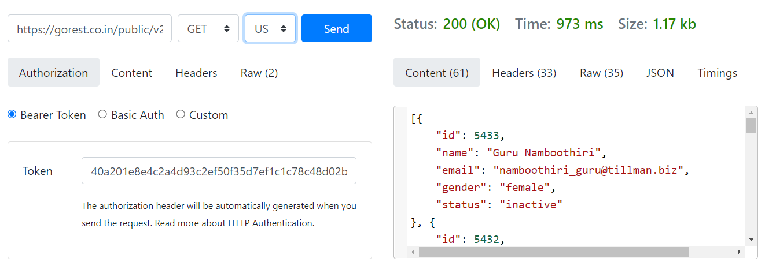

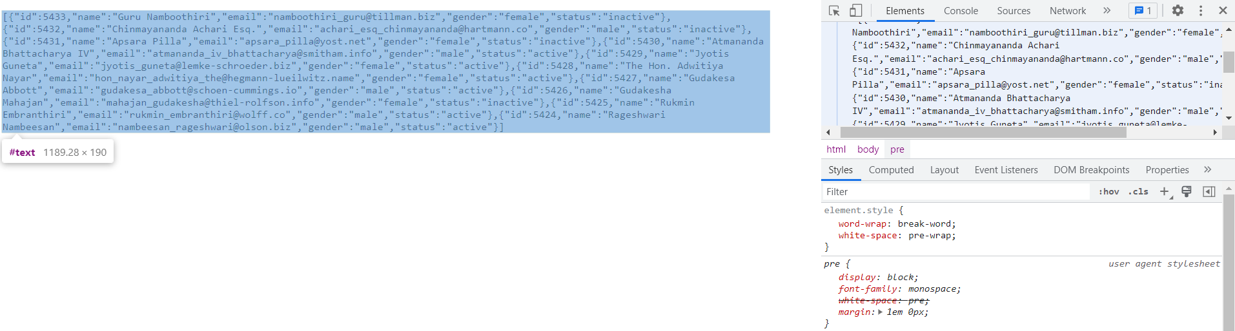

1. **Запит POST**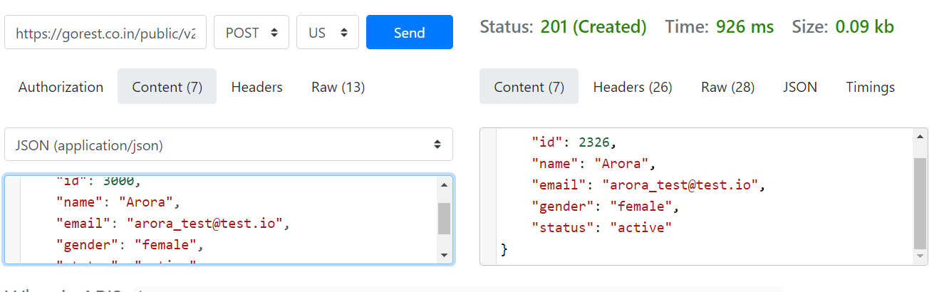

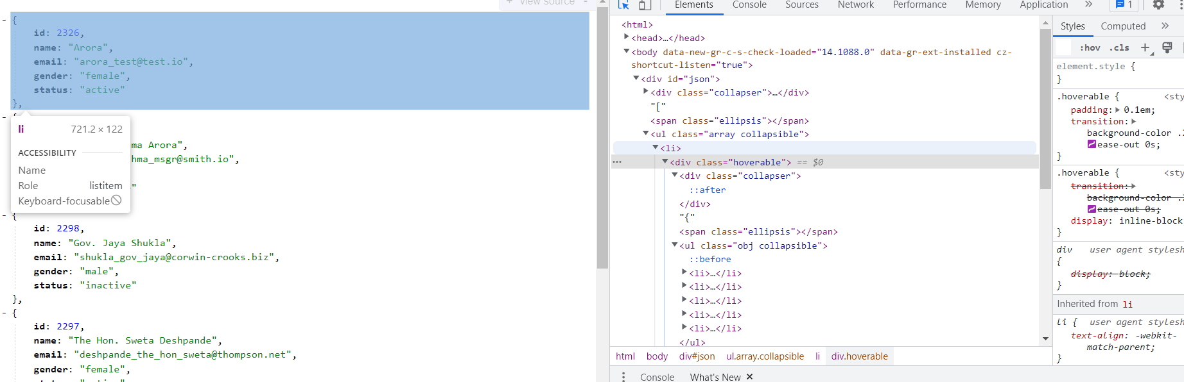

1. **Запит DELETE**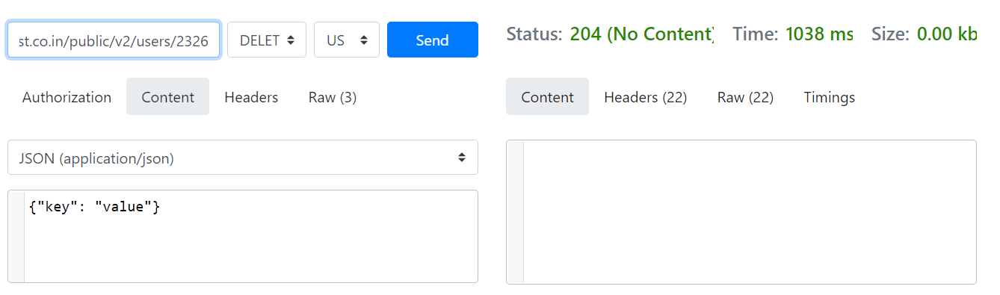

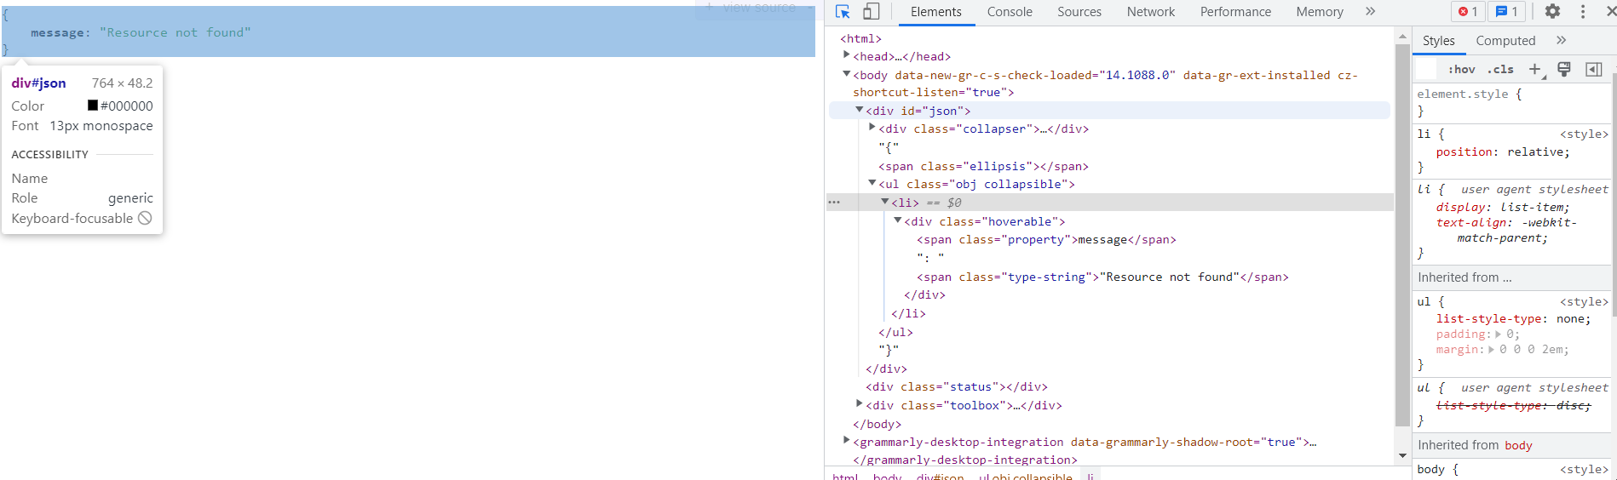

1. **Запит PUT**

